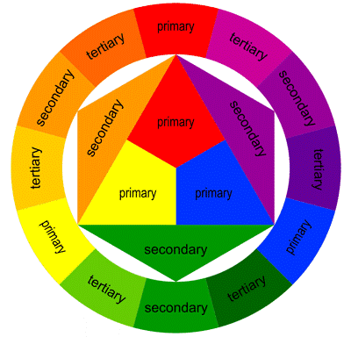
Elements of Design

Colour: What your eyes see when light is reflected off a natural or man-made object. (Primary - Red, Yellow, Blue; Secondary- Orange, Green, Purple; Tertiary- R-O R-P Y-O Y-G B-G B-P)
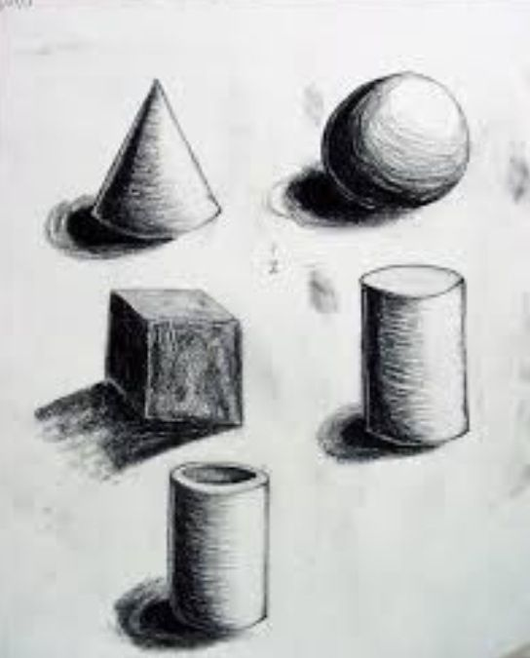

Form: An object that can be defined in three-dimensions (Height, Width, Depth)

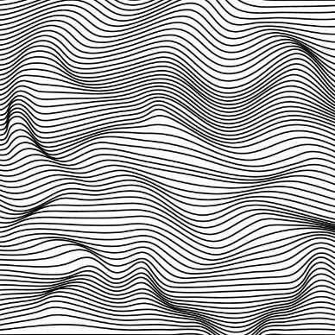

Line: The ends don't meet. Two dimensional (pencil and paper); 3-D like a wire sculpture; implied (the edge of a shape)

Mass: Volume that has (or gives the illusion of having) weight, density and bulk

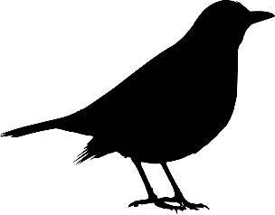
Shape: Defined by lines that connect (Organic=free-flowing, irregular OR Geometric=regular: ie triangle, circle, etc.)

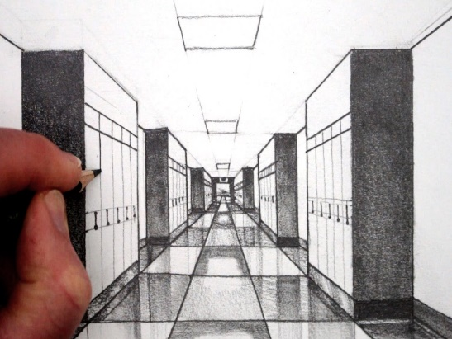

Space: The distance between identifiable points or planes. Illusion of depth (Perspective, Overlapping, Size, Position)

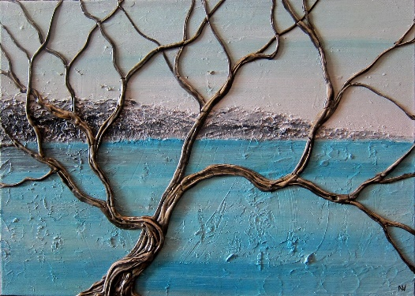
Texture: Surface quality; Tactile texture (touch); Visual texture (see); Examples (Smooth, Rough)

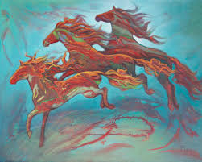
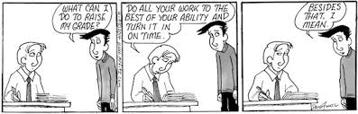
Time and motion: communicating a passage of time (telling a story, a series of events). Also motion: Implied (Blur lines,etc) and Kinetic (Moves)

Value: lightness and darkness of an area
Smooth pencil shading
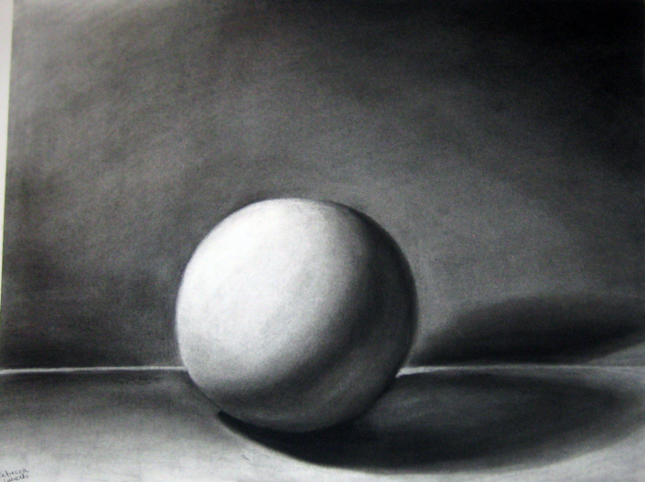
Stippling (dots)
Hatching (lines)

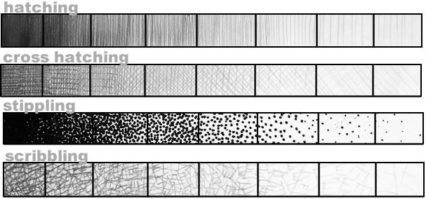

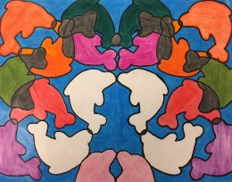
Principles of Design

Symmetrical balance: mirror image (same on both sides)

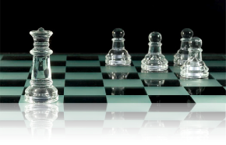
Asymmetrical balance: Different on either side, but has a visual balance through shapes, colours, density, etc…

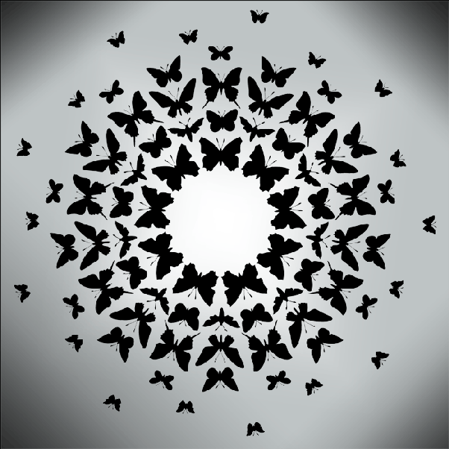

Radial balance: Comes from the centre of the work & often creates a circle

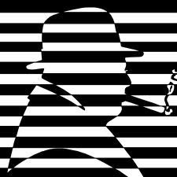

Contrast: Opposites (often elements or art) for example: texture, colour, shapes…

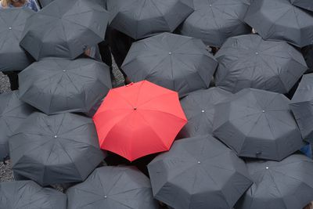

Emphasis: Intentionally drawing your attention to a specific area (similar to focal point)

Pattern: Elements that are repeated in a predictable way (like wallpaper)

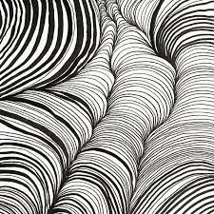
Rhythm: Repetition of elements (not as predictable as pattern) & often size or shapes can be altered

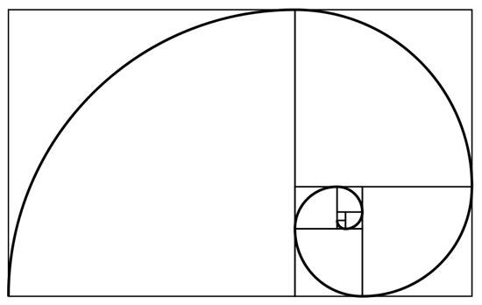
Proportion: size comparisons, measurements

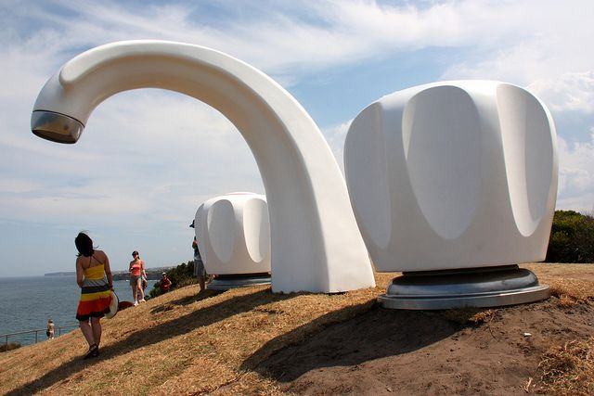
Scale: Monumental = important & Small= intimate or insignificant. Artist uses scale to tell a story or send a message

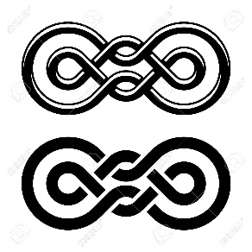

Unity: Everything fits, it looks like it all belongs together

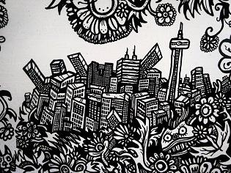

Variety: Diversity of different ideas, mediums and/or elements in a work

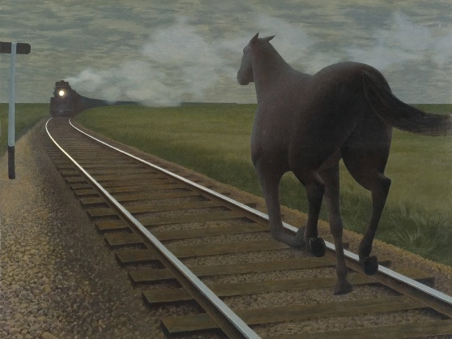

Movement: The viewer's eye is led through a work of art in an organized way. There is often a focal point. The artist through lines, edges, shapes, or colours can direct movement.

